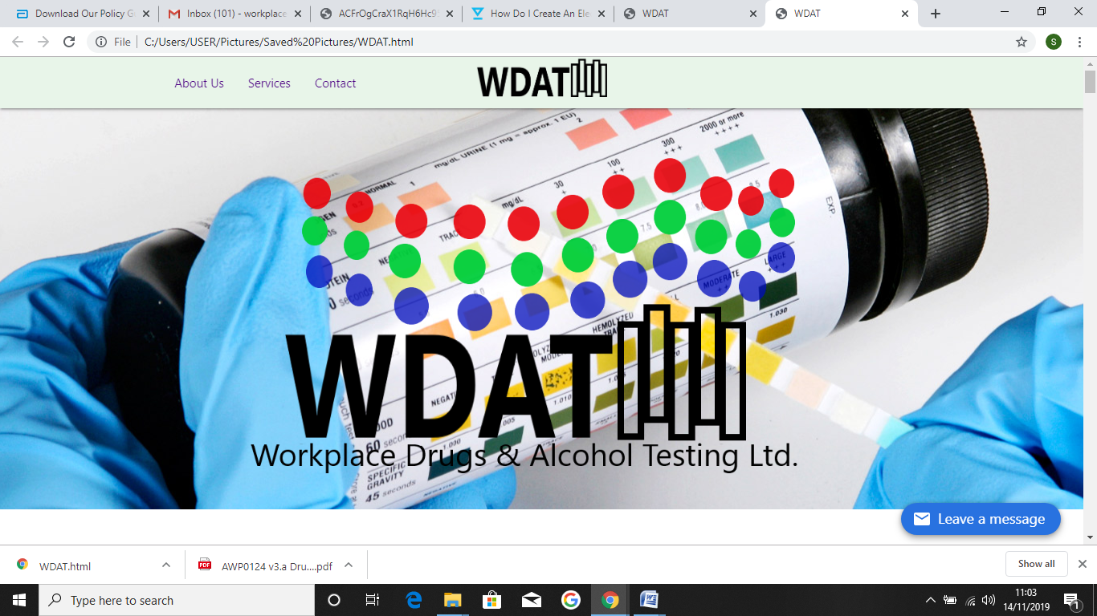

Waste Management Policy

**Workplace Drugs & Alcohol Testing LTD (WDAT)**

**Contents**

1. Introduction

2. Policy Statement

3. Policy Objectives

4. Application

5. Organisation and Management

6. Glossary of Terms

**Waste Management Policy**

**1. Introduction**

Due to the diverse nature of activities undertaken by WDAT, a variety of wastes are produced and collected, ranging from general wastes and recyclable materials, through to clinical offensive wastes. The Company has a duty to ensure that all of these wastes are disposed of responsibly, using approved, registered waste contractors.

This policy sets down the framework for all waste management carried out by WDAT.

**2. Policy Statement**

The Company will adopt the principles of the ‘best practicable environmental option’ in the delivery of its waste management services. The Company will apply a ‘waste hierarchical approach’, to reduce, reuse, recycle and recover waste products in preference to the disposal of waste to landfill.

There is a legal requirement for all who produce, keep or dispose of waste of any type to comply with the various regulations and the Duty of Care under Environmental Protection legislation. The Company recognises the importance of meeting these legal requirements and to manage its waste responsibly, reduce the volume of waste sent to landfill and maximise reuse and recycling where possible.

The Company requires all staff and supply chain partners to comply with this Policy and associated Company Environmental Guidance Notes (EGN’s), to ensure compliance with all waste legislation. In accordance with the Policy Statement WDAT will fulfil the following Policy Objectives.

**3. Policy Objectives**

The objectives of this policy are:

* To ensure that waste management is performed in accordance with all waste legislative requirements, including the duty of care, and to plan for future legislative changes and to mitigate their effects.
* To minimise waste generation at source and facilitate repair, reuse and recycling over the disposal of wastes, where it is cost effective.
* To provide clearly defined roles and responsibilities to identify and co-ordinate each activity within the waste management chain.
* To promote environmental awareness in order to increase and encourage waste minimisation, reuse and recycling.
* To ensure the safe handling and storage of wastes at all office locations and construction sites.
* To provide appropriate training for staff, supply chain partners and clients on waste management issues.
* To promote industry waste management best practice.
* To appoint competent person(s) to provide waste management advice.

**4. Application**

This policy applies to all activities undertaken by (or on behalf of) WDAT including its staff, supply chain partners and clients.

**5. Organisation and Management**

The responsibilities and organisational arrangements for this Waste Management Policy lie with a variety of personnel within the Company.

Managing Director

The Managing Director is accountable to the Board for the Waste Management and Environmental performance of the Company. In particular this will require him to:

* Ensure the Company has a comprehensive, up to date Waste Management policy and Environmental policy that meets statutory obligations.
* Ensure that the policies contain a demonstration of his personal commitment by the inclusion of a signed and dated Policy Statement.
* Review the Policies to ensure that they remain comprehensive, relevant and up to date.
* Assign duties to key personnel to apply the Policies throughout the Company.

**2.3 Directors / Heads of Departments**

All directors and heads of departments are accountable to the Managing Director for the implementation of this Policy in their respective functions. In particular, this will require them to:

* Demonstrate their implementation of the requirements of this Policy
* Ensure that the personnel under their control are competent and provided with adequate support, supervision, information, instruction and training to execute their work without risk to the environment and abiding by the contents of waste management plan specific to the projects that they work on.
* Ensure that all activities for which they are responsible, including pre-contract and head office processes are, where appropriate, subject to the production of a site waste management plane, formal hazard identification and risk assessment.
* Ensure the implementation of the Company’s environmental management system and waste management policy contained within this document.

**2.4 Personnel Manager**

The Personnel Manager is accountable to the Managing Director for implementing the relevant requirements of this Policy

. In particular, this will require him to:

* Liaise with Directors, in monitoring the training needs of employees.
* Maintain records of employee environmental and health & safety training,
* Provide all new employees with a copy of this Policy

**2.7 Employees**

All employees are accountable through the management structure for conforming to the requirements of this policy and of statutory requirements. In particular, every employee is required to:

* Take care and attention of the environment.
* Co-operate in fulfilling the company’s pursuit of continuous environmental and waste management improvement.
* Be familiar with and implement this policy.
* Conform to the requirements of the project environmental and waste management plan, where applicable.

**Glossary of Terms**

**1. Best Practicable Environmental Option (BPEO)**

The Best Practicable Environmental Option refers to the analysis of different methods of waste disposal. The preferred option is the one which minimises harm to the environment as a whole, taking into account what is affordable and practicable.

**2. Clinical Waste**

Any waste which consists wholly or partly of:

* human or animal tissue;
* blood or other body fluids;
* excretions;
* drugs or other pharmaceutical products other than controlled or cytotoxic drugs
* swabs or dressings;
* syringes, needles or other sharp instruments; which unless rendered safe may prove hazardous to any person coming into contact with it. It also includes any other waste arising from medical, nursing, dental, veterinary, pharmaceutical or similar practice, investigation, treatment, care, teaching or research, or the collection of blood for transfusion, being waste which may cause infection to any person coming into contact with it.

**3. Environmental Protection Act 1990 (EPA 1990)**

This is the single most important piece of environmental legislation and it controls many aspects of how the environment is protected and regulated. The EPA 1990 (amended 1995) provides the main statutory framework in relation to waste. The majority of waste leaving the Site is controlled waste. This is described in the EPA 1990 as the waste arising from household, commercial or industrial premises. Controlled waste includes waste from offices, food handling, shops and other domestic activities. EPA 1990 Section 34 imposes a “Duty of Care” on producers and handlers of waste, “to take reasonable measures to prevent the unauthorised deposit, treatment or disposal of waste.” This means the following:

1. The Site must keep records of how much waste it is generating.

2. The Site must ensure that a registered carrier collects their waste.

3. The Site must ensure that all transfer notes are completed and filed detailing the type of waste for disposal. These must be kept for three years.

4. Ensure that all waste is dealt with in accordance with the “Duty of Care”. Breach of the Duty of Care is a criminal offence and can incur penalties of up to £20,000 or an unlimited fine if convicted on indictment.

**4. Hazardous Waste**

These are the most dangerous wastes as they can cause the greatest environmental damage or are dangerous to human health. These wastes are listed in The List of Wastes (England) Regulations 2005. Some common hazardous wastes are listed below:

* Acids Pesticides Fluorescent Tubes
* Alkaline Solutions Photographic Chemicals Televisions
* Batteries Waste Oils Paint
* Solvents Computer Monitors

Other hazardous wastes, such as asbestos and radioactive substances, are subject to their own specific legislation.

**5. Recycling**

The diversion of waste away from landfill or incineration and the reprocessing of those wastes either into the same product or a different one. This mainly includes nonhazardous wastes such as paper, glass, cardboard, plastic and scrap metal.

**6. Responsible Person**

The person who oversees the wastes to be removed from the premises at which it was produced or is being held.

**7. Waste**

The legal definition of waste comes from Section 75(2) of the Environmental Protection Act 1990 (EPA 1990). It defines waste as any substance or object which the holder discards, intends to discard or is required to discard. The EPA 1990 refers to ‘controlled wastes’ which are split into four categories: Household, commercial, industrial and clinical waste. The Site produce waste in all four categories. There are some waste which are exempted as they have their own separate legislation e.g. radioactive wastes.

**8. Waste Hierarchy**

The hierarchy lists the different ways of dealing with waste in order of preference.

1. Reduce Also known as waste minimisation, to reduce the amount of waste materials being produced.

2. Re-use To continually re-use an item in order to eliminate the use of resources in making new items.

3. Recovery Recycling – The collection and reprocessing of wastes either into the same product or a different one. Composting – biological decomposition of organic material to create a soil conditioner. Energy – waste is incinerated and the heat is recovered to generate energy.

4. Disposal Waste is sent, untreated, to landfill.

This policy has been prepared and signed by;



**Sarah Ketley**

**Managing Director WDAT**

**Date: Revised November 2020**